REF: AMMEND/Dta.2.1-08
DATE:25/JAN/08

AMMENDMENT UPDATE FOR STATIC DATA 2.1.

This documentation modification replaces the section contained in the manual Static Data 2.1. Please update accordingly.

25.2.1 Search Car Locations attributes/parameters
A Search Car Locations request can contain attributes/parameters to filter the locations returned.
The request can contain the following attributes/parameters: -

Parameters | Description
Date | Mandatory. Date when the car will be collected.
Supplier | Mandatory. Supplier Code
City | Mandatory. GTA city code where the car will be collected.
Category | Mandatory. The valid values for this are defined within the schema and consist of the following:  A – Airport  C – City Centre  S – Suburbs  X – Rail Station  P – Port  R – Resort  T – Terminal  O – Off-Terminal  NS – North Suburbs  SS – South Suburbs  ES – East Suburbs  WS – West Suburbs
 | Attribute | Description
 | AirportCode | Mandatory if the airport code is different to the city code.

28. Search Car Supplier Information

28.1 Overview
The Search Car Supplier Information provides the client with details of a car supplier for a given country.

28.2 XML Search Car Supplier Information request
The XML message below gives a sample of the expected elements needed by the API to execute a Search Car Supplier Information Request.

<?xml version="1.0" encoding="UTF-8"?>
<Request>
<Source>
<RequestorID Client="123456" EMailAddress="clientName@client.co.uk" Password="clientPassword" />
<RequestorPreferences Language="en">
<RequestMode>SYNCHRONOUS</RequestMode>
</RequestorPreferences>
</Source>
<RequestDetails>
<SearchCarSupplierInformationRequest>
<Date>2007-06-01</Date>
<Supplier>EP</Supplier>
<Country>GB</Country>
<City></City>
<Acriss>L</Acriss>
</SearchCarSupplierInformationRequest>
</RequestDetails>
</Request>

28.2.1 Source parameters
Please refer to the API Architecture document.

28.2.2 Search Car Supplier Information parameters
This request will be used to retrieve information for the car supplier through the API for given search criteria. One or more of the following sub-elements must be specified: -

Element | Description
Date | Optional. If not entered will default to today’s date.
Supplier | Mandatory.
Country | Mandatory. Country code in ISO 3166 format, 2 letters.
City | Optional. This will limit the response details to those that pertain to the city within the country (i.e. the AgeLimits).
Acriss | Optional. This will limit the response details to information that corresponds to the Acriss letters entered (see section on Acriss Code).  Any combination of Class, Type, Transmission and Air Conditioning is allowed, for example: -  - “L” - just Luxury class  - “CC” – just Compact class with type of 2/4 Doors  - “S*A” – just Standard class with transmission of Automatic

28.3 Example XML Car Supplier Information response
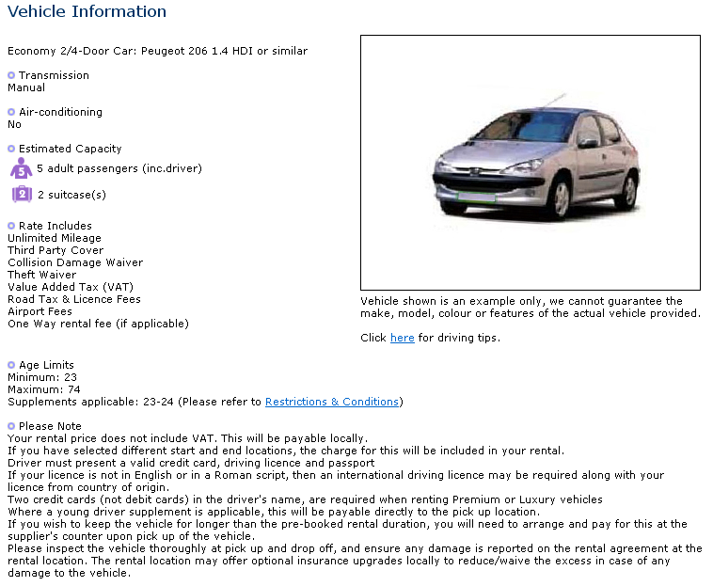
The XML message below gives a sample of that given by the API in response to a Search Car Supplier Information Request for the web example above

<?xml version="1.0" encoding="UTF-8" ?>
<Response ResponseReference="REF_1479-84215-715721789196454">
<ResponseDetails Language="en">
<SearchCarSupplierInformationResponse>
<CarSupplierDetails Country="GB">
<Supplier>EP</Supplier>
<Description>
<![CDATA[EUROPCAR]]>
</Description>
<RateIncludes>
<RateInclude Code="UNL">
<![CDATA[Unlimited Mileage]]>
</RateInclude>
<RateInclude Code="TPC">
<![CDATA[Third Party Cover]]>
</RateInclude>

+++++++

</RateIncludes>
<AgeLimits>
<AgeLimit Acriss="****" MinimumAge="23" SupplementAge="24" MaximumAge="74" />
<AgeLimit Acriss="FVM*" MinimumAge="25" SupplementAge="24" MaximumAge="74" />
<AgeLimit Acriss="L***" MinimumAge="30" SupplementAge="24" MaximumAge="74" />
<AgeLimit Acriss="P***" MinimumAge="30" SupplementAge="24" MaximumAge="74" />
<AgeLimit Acriss="X***" MinimumAge="30" SupplementAge="24" MaximumAge="74" />
</AgeLimits>
<PleaseNotes>
<PleaseNote Code="NOVAT">
<![CDATA[Your rental price does not include VAT. This will be payable locally.]]>
</PleaseNote>
<PleaseNote Code="STRTEND">
<![CDATA[If you have selected different start and end locations, the charge for this will be included in your rental.]]>
</PleaseNote>

++++++++++

</PleaseNotes>

<Links>
<ImageLinks>
<ImageLink Acriss="C***">
<Text>
<![CDATA[Compact : Toyota Corolla 2.0 Terra or similar]]>
</Text>
<ThumbNail>
<![CDATA[http://images.test.octopustravel.com/CarHire/LON_EURO09/_C_THUMBNAIL.jpg]]>
</ThumbNail>
<Image>
<![CDATA[http://images.test.octopustravel.com/CarHire/LON_EURO09/_C.jpg]]>
</Image>
</ImageLink>

++++++++++

</ImageLinks>
</Links>
</CarSupplierDetails>
</SearchCarSupplierInformationResponse>
</ResponseDetails>
</Response>

28.4 Car Supplier Information response

28.4.1 Search Car Supplier Information response parameters
The API will return the following sub-elements: -

Element | Description
CarSupplierDetails | This will contain the details for the car supplier (for the country code).
 | Attribute | Description
 | Country | Identifies the country code

28.4.2 CarSupplierDetails sub-element

Element | Description
Supplier | The external supplier code.
Description | The external supplier name.
RateIncludes | A list of Rate Include elements that contain: -  The Rate Include description.  - Code – the API code for the Rate Include.
AgeLimits | A list of Age Limit elements that contain the following attributes:  - City – Only output if age limits apply to a specific city within the country.  - Acriss – the Acriss code. If Acriss selection is entered as part of the request, the Age Limits are restricted to those that match.  - MinimumAge – the minimum age.  - SupplementAge – the supplement age.  - MaximumAge – the maximum age.
PleaseNotes | A list of Please Note elements that contain: -  The Please Note description.  - Code – the API code for the Rate Include.
Links | See below.

28.4.3 Links sub-element
The Links sub-element within the CarSupplierDetails contains a list of <ImageLink> within the <ImageLinks> element. This represents a list of car images available for hire through the supplier – within the country.

28.4.3.1 ImageLink sub-element

Attribute | Description
Acriss | The Acriss code. If Acriss selection is entered as part of the request, the Image Links are restricted to those that match (see Acriss selection below).

Element | Description
Text | The car description.
ThumbNail | The url for the thumbnail car image.
Image | The url for the car image.

28.5 Acriss selection
For a breakdown of Acriss code see the section on Acriss Code.

28.5.1 Acriss filtering
The response can be restricted to show only information that corresponds to an Acriss code or partial Acriss code. For example: -

Acriss | Description
Not entered | No filtering of information.
“L” | Only Acriss codes for Luxury class are shown.
“CC” | Only Acriss codes for Compact class where type is 2/4 Door (and where the type is unknown – indicated by “*”) are shown.
“S*A” | Only Acriss codes for Standard class where transmission is Automatic (and where the transmission is unknown – indicated by “*”) are shown.

28.5.2 Acriss filtering examples
To further explain how the filtering of Acriss codes functions, an example list of existing Acriss Codes held for car images is given below and then a number of different Acriss code filters and their corresponding results: -

Acriss
S***
SD**
SDAR
SDMR
SV**
SW**
SWMR

Acriss filter | Result
“S” | All the above Acriss codes
“SD” | S***  SD**  SDAR  SDMR
“SDA” | S***  SD**  SDAR
“S*A” | S***  SD**  SDAR  SV**  SW**

29. Search Car Supplier Link Information

29.1 Overview
The Search Car Supplier Link provides the client with car images for a given country.

29.2 XML Search Car Supplier Link request
The XML message below gives a sample of the expected elements needed by the API to execute a Search Car Supplier Link Request.

<?xml version="1.0" ?>
<Request>
<Source>
<RequestorID Client="1479" EMailAddress="JOHN@NTLWORLD.COM" Password="JJL"/>
<RequestorPreferences Language="en" Currency="GBP" Country="GB">
<RequestMode>SYNCHRONOUS</RequestMode>
</RequestorPreferences>
</Source>
<RequestDetails>
<SearchCarSupplierLinkRequest>
<Country>GB</Country>
<Supplier>EP</Supplier>
<Acriss>L</Acriss>
</SearchCarSupplierLinkRequest>
</RequestDetails>
</Request>

29.2.1 Source parameters
Please refer to the API Architecture document.

29.2.2 Search Car Supplier Link parameters
This request will be used to retrieve link information through the API for given search criteria. One or more of the following sub-elements must be specified: -

Element | Description
Country | Mandatory. Country code in ISO 3166 format, 2 letters.
Supplier | Optional.
Acriss | Optional. This will limit the response details to information that corresponds to the Acriss letters entered (see section on Acriss Code).  Any combination of Class, Type, Transmission and Air Conditioning is allowed, for example: -  - “L” - just Luxury class  - “CC” – just Compact class with type of 2/4 Doors  - “S*A” – just Standard class with transmission of Automatic

29.3 Example XML Car Supplier Link response
The XML message below gives a sample of that given by the API in response to a Search Car Supplier Link Request for the web example above.
<?xml version="1.0" encoding="UTF-8" ?>
<Response ResponseReference="REF_1479-84216-715721789196454">
<ResponseDetails Language="en">
<SearchCarSupplierLinkResponse>
<LinkDetails>
<LinkDetail>
<Country Code="GB">
<![CDATA[United Kingdom]]>
</Country>
<Supplier Code="EP">
<![CDATA[EUROPCAR]]>
</Supplier>
<Links>
<ImageLinks>
<ImageLink Acriss="C***">
<Text>
<![CDATA[Compact : Toyota Corolla 2.0 Terra or similar]]>
</Text>
<ThumbNail>
<![CDATA[http://images.test.octopustravel.com/CarHire/LON_EURO09/_C_THUMBNAIL.jpg]]>
</ThumbNail>
<Image>
<![CDATA[http://images.test.octopustravel.com/CarHire/LON_EURO09/_C.jpg]]>
</Image>
</ImageLink>

++++++++++

</ImageLinks>
</Links>
</LinkDetail>
</LinkDetails>
</SearchCarSupplierLinkResponse>
</ResponseDetails>
</Response>

29.4 Car Supplier Link response

29.4.1 Search Car Supplier Link response parameters
The API will return a list of <LinkDetail> elements within the <LinkDetails> sub-elements.
Each <LinkDetail> will contain the car images for a Country and Supplier, represented by the following sub-elements: -

Element | Description
Country | This will contain the country name.
 | Attribute | Description
 | Code | Identifies the country code
Supplier | This will supplier name.
 | Attribute | Description
 | Code | Identifies the external supplier code.
Links | See below.

29.4.2 Links sub-element
The Links sub-element within the CarSupplierDetails contains a list of <ImageLink> within the <ImageLinks> element. This represents a list of car images available for hire through the supplier – within the country.

29.4.2.1 ImageLink sub-element

Attribute | Description
Acriss | The Acriss code. If Acriss selection is entered as part of the request, the Image Links are restricted to those that match (see Acriss selection below).

Element | Description
Text | The car description.
ThumbNail | The url for the thumbnail car image.
Image | The url for the car image.

29.5 Acriss selection
For a breakdown of Acriss code see the section on Acriss Code.

29.5.1 Acriss filtering
The response can be restricted to show only information that corresponds to an Acriss code or partial Acriss code. For example: -

Acriss | Description
Not entered | No filtering of information.
“L” | Only Acriss codes for Luxury class are shown.
“CC” | Only Acriss codes for Compact class where type is 2/4 Door (and where the type is unknown – indicated by “*”) are shown.
“S*A” | Only Acriss codes for Standard class where transmission is Automatic (and where the transmission is unknown – indicated by “*”) are shown.

29.5.2 Acriss filtering examples
To further explain how the filtering of Acriss codes functions, an example list of existing Acriss Codes held for car images is given below and then a number of different Acriss code filters and their corresponding results: -

Acriss
S***
SD**
SDAR
SDMR
SV**
SW**
SWMR

Acriss filter | Result
“S” | All the above Acriss codes
“SD” | S***  SD**  SDAR  SDMR
“SDA” | S***  SD**  SDAR
“S*A” | S***  SD**  SDAR  SV**  SW**

30. ACRISS CODE

30.1 ACRISS – Car Classification Code
The ACRISS Car Classification Code is a code used by many car rental companies, including Avis, Hertz, Alamo, Europcar and National, for classifying a certain category of vehicles. The code has four letters.
- First letter: Class
  - M = Mini
  - E = Economy
  - C = Compact
  - I = Intermediate
  - S = Standard
  - F = Full Size
  - P = Premium
  - L = Luxury
  - X = Special
- Second letter: Type
  - B = 2 Doors
  - C = 2/4 Doors
  - D = 4 Doors
  - W = Wagon
  - V = Van (6+ passengers)
  - L = Limousine
  - S = Sport
  - T = Convertible
  - F = 4-Wheel Drive
  - P = Pick Up
  - J = All Terrain
  - K = Van (cargo)
  - X = Special
- Third letter: Transmission
  - A = Automatic
  - M = Manual
- Fourth letter: Air Conditioning
  - R = Yes
  - N = No

